Chapter 10, Solution 73.

As a voltage follower, 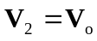

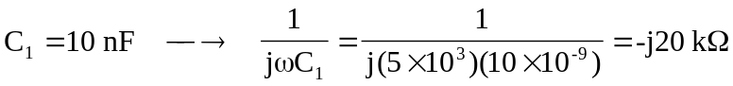
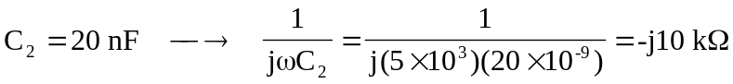

Consider the circuit in the frequency domain as shown below.
+
-
+
-
10 kW
20 kW
-j10 kW
I_{s}
V_{o}
V₂
V₁
I_{o}
-j20 kW
Z_{in}
V_{S}

At node 1,
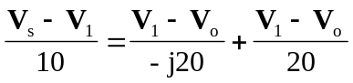
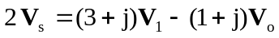 (1)

At node 2,
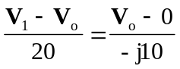
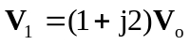 (2)

Substituting (2) into (1) gives
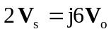 or 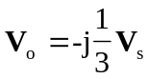

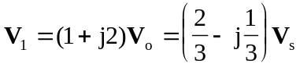

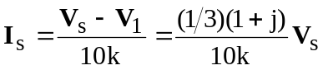
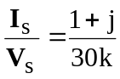

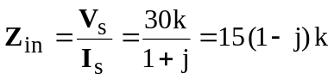
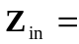 21.21Ð–45° kW

